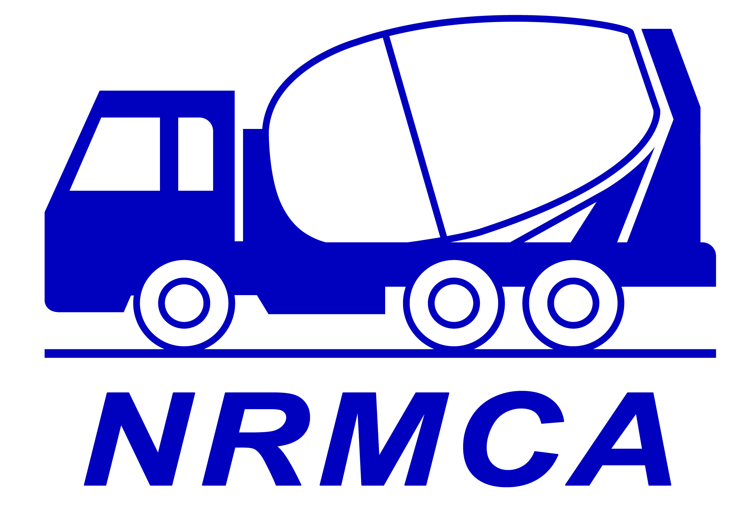
NATIONAL READY-MIXED CONCRETE ASSOCIATION OF MALAYSIA

PERSATUAN KEBANGSAAN KONKRIT SIAP BANCUH MALAYSIA

Introduction to Concrete Technology

8.30 am Registration of participants.

9:00 am Historical Perspective of Concrete.

9:45 am What is Concrete?

10.00 am Tea Break

10.15 am Materials for Concrete

Cement
Aggregate & Sand
Water for Making Concrete
Admixtures

11:30 am Production of Concrete

Types of Batching Plants

Material Receiving & Storage

Production Flow

Batching & Mixing

12:30 pm Lunch break

1:30 pm Properties of Concrete
Fresh Concrete
Workability
Cohesiveness
Segregation & Bleeding
Setting
Curing

Hardened Concrete Durability

3.30 pm Tea Break

3.45 pm Concrete Problem at Site
Action to Verify Concrete Quality
Action Relating to Valid Compliance Failure
Questions and Answers

5.00 pm End

NATIONAL READY-MIXED CONCRETE ASSOCIATION OF MALAYSIA

PERSATUAN KEBANGSAAN KONKRIT SIAP BANCUH MALAYSIA

Introduction to Concrete Technology

OBJECTIVE
This course aims to introduce the essence of concrete technology to new comers of the concrete industry. It also helps to enhance the operatives working in the concrete batching plants to have a more complete picture of the industry.

Ready mixed concrete companies are encouraged to send all their employees including sales, human resource, finance and administrative staff to attend this training in order that they are at the least familiar with the industry they are employed for.

Related trades such as cement, sand and aggregate suppliers are also encouraged to attend this course to gain a basic knowledge of the industry which is by far the most important customers of theirs.

OVERVIEW
Named as “Introduction to Concrete Technology”, this course covers historical perspective of concrete, materials for concrete, production of concrete with different types of batching plants and action to tackle the site problems of concrete..

TARGET GROUP
This course targets to bring the basic knowledge of the concrete technology to all new comers. All those who are employed in the ready-mixed concrete industry ought to attend this course.

FEES
*Members of NRMCA: RM330.00 + 6% GST per participant
*Non-members: RM380.00 + 6% GST per participant.
Participant will be presented with a Certificate of Attendance

VENUE

NRMCA Training Room,
13-1, 1st Floor, Jalan Sepah Puteri 5/1 B,
Pusat Dagangan Seri Utama PJU 5,
Kota Damansara, 47810 Petaling Jaya,
Selangor Darul Ehsan, Malaysia.

NATIONAL READY-MIXED CONCRETE ASSOCIATION OF MALAYSIA

PERSATUAN KEBANGSAAN KONKRIT SIAP BANCUH MALAYSIA

Introduction to Concrete Technology

Bio Data of the Trainer

Mr. Ting Hong Yew

Ting Hong Yew was the Deputy General Manager of Mega Pascal Berhad till May 2005. He graduated with Diploma in Advanced Concrete Technology from Institute of Concrete Technology, United Kingdom in 1993, Diploma in Management from Malaysian Institute of Management, KL in 1998, and he obtained a Master degree in Business Administration from University of Sunderland, London in 2003. Mr. Ting is a member of Institute of Concrete Technology (MICT), United Kingdom since 1993 and a Licentiate of City & Guild Institute, London in 1995. He has more than fifteen years’ working experience in ready-mixed concrete industry. He began his career as Concrete Technician in Sykt. Siap Kon Sdn Bhd and a year later, he was promoted to Plant Supervisor and subsequently to Quality Controller, responsible for quality related activities (1985-1989). He also worked as Quality Control Executive with Sun-Mix Concrete Sdn Bhd (1989-1993) and joined Cygal Concrete Sdn Bhd as Technical Manager (1993-1994) before joining Mega Pascal Bhd as Operations Manager in 1994.

Currently, he is a partner of B S EN Test Sdn Bhd. The company provides testing services mainly for the construction industry

INTRODUCTION TO CONCRETE TECHNOLIOGY

Date : Thursday 16 Feb 2017
Time : 9.00 a.m. to 5.00 p.m.
Venue : Training will be conducted at NRMCA Training Room, Kota D’sara

1. Name: ____________________________________________________

Position: __________________________________________________

2. Name: ____________________________________________________

Position: __________________________________________________

3. Name: ____________________________________________________

Position: __________________________________________________

4. Name: ____________________________________________________

Position: __________________________________________________

Company: _________________________________________________

Address: __________________________________________________

__________________________________________________

Contact Person: ____________________Mobile: __________________

Contact Email: _____________________Tel: _____________________

Course Fees

- Fees: NRMCA Member RM330 + 6% GST. Non-Member RM380 + 6% GST
- Fees are inclusive of training materials, luncheons, morning and afternoon breaks.
- All payment must be made in favour of “NRMCA” and bank in to Hong Leong Bank account No. 369 0000 5264
- Kindly fax the bank in slip together with your company address to Mr. Daniel Lee at 603 7960 7882 or email to finance@novabizservices.com in order for NRMCA to identify your
payment and issue receipt accordingly.
- You may send your cheque to: National Ready-Mixed Concrete Association of Malaysia,
C/o Nova Business Services Group Sdn. Bhd. Block A-31-05,
Dataran 3 Two, No. 2, Jalan 19/1, 46300 Petaling Jaya, Selangor D E

SBL Scheme
Companies must apply directly to HRDF. SBL Scheme will be based on the individual merit of each application.

For Registration & Enquiry,
Please Contact: Mr. Eric Wong
Mobile: 019 357 5793; email: nrmcam@gmail.com

